Contents
1.Cover page 1
2. Introduction & Objectives 1
3.Technology & Tool Installation 2
4.Activity Practice 1: Defining Layers and Responsibilities 2
5.Activity Practice 2: Component Identification (Generate Unified Price Prediction) 3
6.Activity Practice 3: Component Diagram Modeling 6
7. Link to Architecturally Significant Requirements (ASRs) from Lab 1 7
8. Conclusion & Reflection 7

1.Cover page
- Title: Design and Evaluation of Multi-Agent Architecturesfor Stock Price Prediction: A Vietnam Case Study
- Course information: Software Architecture
- Student Details: Nguyen Minh Duong, ID: 23010441
- Date: 12/2025

2. Introduction & Objectives
This lab focuses on designing the Layered Architecture for the Multi-Agent Stock Price Prediction System, representing the system's static structure and component relationships. This is a crucial step before implementation (Lab 3). The design adapts the layered pattern to support the coordination architectures (Hierarchical, Round Robin, Ensemble Voting) identified in Lab 1, ensuring modularity, flexibility (ASR-1), and modifiability (ASR-3) while addressing real-time interaction (ASR-2).
Objectives
- Understand the principles and constraints of the Layered Architecture Pattern.
- Define the four main layers and their responsibilities.
- Identify the key components within each layer for the "Generate Unified Price Prediction" feature (based on FR-03).
- Model the logical view using a UML Component Diagram.

3.Technology & Tool Installation
Tool | Purpose | Installation/Setup Guide
draw.io (Diagrams.net) | Creating professional UML Component Diagrams. | Access online via a web browser (no install needed) or use the desktop application.
Whiteboard/Pen & Paper | Initial brainstorming and sketch of layers/components. | Standard brainstorming tools.

4.Activity Practice 1: Defining Layers and Responsibilities

Goal: Formally define the four layers and their roles in the system.

Layer | Purpose/Responsibility | Output/Artifact
1. Presentation Layer (UI/API) | Handles HTTP/API requests, authentication, session management, renders predictions & charts | Controllers (e.g., PredictionController)
2. Business Logic Layer (Domain/Service) | Contains core coordination logic (Hierarchical, Round Robin, Ensemble Voting), business rules, agent orchestration, prediction aggregation | Services (e.g., CoordinationService)
3. Persistence Layer (Data Access) | Maps domain objects to database, performs CRUD on market data, agent outputs, LSTM states | Repositories (e.g., MarketDataRepository)
4. Data Layer | Physical storage (SQLLite for structured data, MongoDB/TimeSeries DB for ticks & news) | Database Schema (Tables/Collections)

Data Flow – User Requests Stock Price Prediction Client Request → Presentation → Business Logic → Persistence → Data Layer → Persistence → Business Logic → Presentation → Client Response

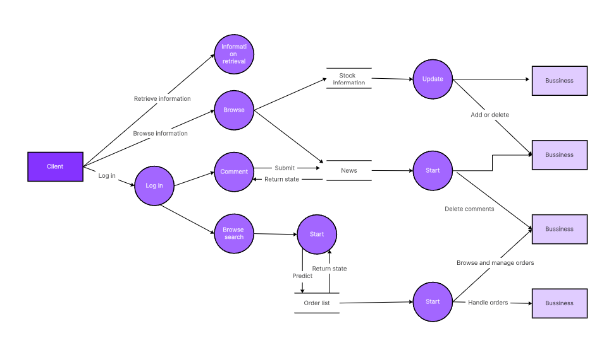

5.Activity Practice 2: Component Identification (Generate Unified Price Prediction)

Goal: Break down the core feature into concrete components in the top three layers.

Layer | Component Name | Responsibility
Presentation | PredictionController | Receives GET /api/predictions/{symbol}?horizon=14d&arch=ensemble Validates input, calls Business Logic
Business Logic | CoordinationService | Loads selected architecture from config Orchestrates agents (Technical, Fundamental, Sentiment, LSTM) Aggregates results using chosen strategy (Hierarchical → Master Agent, Round Robin → sequential, Ensemble → voting)
Persistence | MarketDataRepository | Retrieves historical prices, volume, news sentiment, order-book snapshots for the requested symbol & period

Defined Interfaces
CoordinationService → Presentation

from typing import Optional, Dict, List

class PricePredictor:
def __init__(
self,
name: str = "Price Predictor Agent with LSTM",
vn_api: Optional[object] = None,
stock_info: Optional[object] = None,
ai_agent: Optional[object] = None,
crewai_collector: Optional[object] = None
):
self.name = name
self.vn_api = vn_api
self.stock_info = stock_info
self.ai_agent = ai_agent
self.crewai_collector = crewai_collector

self.prediction_periods: Dict[str, List[int]] = {
"short-term": [1, 3, 7],
"medium-term": [14, 30, 60],
"long-term": [90, 180, 365],
}

# --- Public Interface ---
def get_unified_prediction(self, symbol: str, horizon: str) -> "PredictionResult":
"""Unified prediction API exposed to upper layers."""
pass

# --- Internal Model Interface ---
def predict_lstm(self, symbol: str, periods: List[int]) -> "PredictionResult":
"""Run LSTM model prediction for given periods."""
pass

MarketDataRepository → Business Logic
class MarketDataset:
"""Data model mô phỏng bản ghi giá."""
def __init__(self, date: datetime, open: float, close: float):
self.date = date
self.open = open
self.close = close

class MarketDataRepository(ABC):

@abstractmethod
def find_by_symbol_and_date_range(
self,
symbol: str,
from_date: datetime,
to_date: datetime
) -> List[MarketDataset]:
pass

6.Activity Practice 3: Component Diagram Modeling

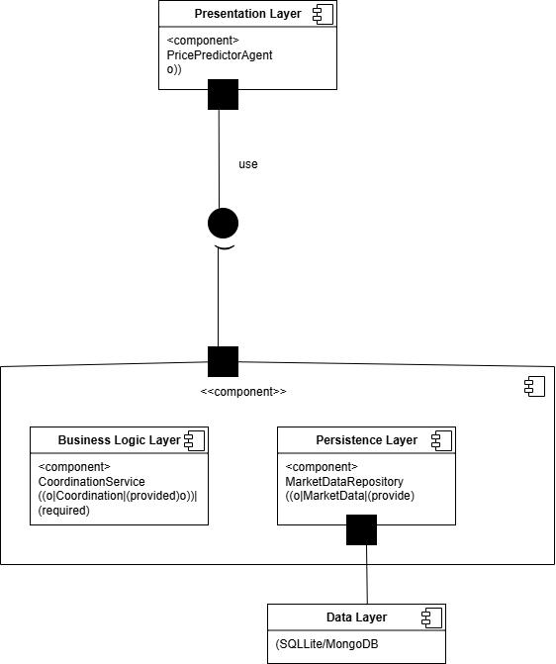

7. Link to Architecturally Significant Requirements (ASRs) from Lab 1
ASR from Lab 1 | How the Layered Design Satisfies It
ASR-1 Flexibility | Switching between Hierarchical, Round Robin, Ensemble Voting is done only a configuration change inside CoordinationService – no impact on Presentation or Persistence layers
ASR-2 Real-time Interaction | All coordination & aggregation logic lives in the Business Logic layer, allowing parallel agent execution and immediate refinement within a single request cycle
ASR-3 Modifiability | Adding a new agent (e.g., MacroEconomicAgent) or new LLM only requires changes inside the Business Logic layer – Presentation and Persistence remain untouched

8. Conclusion & Reflection
In this Lab 2, we successfully applied the strict Layered Architecture Pattern to the Multi-Agent Stock Price Prediction System while preserving the flexibility for the three coordination architectures required by the project.
The resulting design:
- Enforces separation of concerns
- Guarantees downward-only dependencies
- Fully supports ASR-1 (runtime architecture switching), ASR-2 (real-time agent interaction), and ASR-3 (easy addition of new agents or models)
- Provides a clean, maintainable foundation for Lab 3 where we will implement the Hierarchical, Round Robin, and Ensemble Voting coordination strategies inside CoordinationService.
The system is now ready for component implementation and subsequent integration of Agent-Driven Architecture

